# Visvesvaraya Technological University, Belagavi Government Engineering College, Hassan 573201

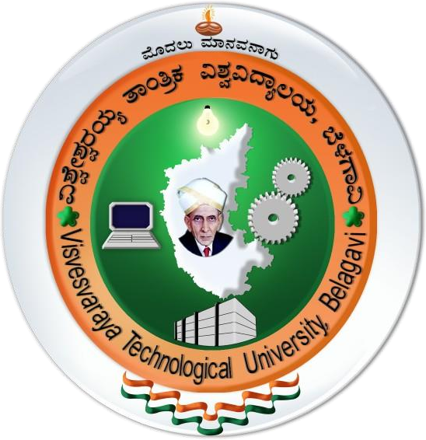

**Mini Project Synopsis On**

**“CLUB’S MANAGEMENT SYSTEM”**

Submitted in Partial Fulfillment of Fifth Semester Database Management System Laboratory(17CSL58) in Computer Science & Engineering

# Aishwarya Jain 4GH17CS003

# Gowtham H M 4GH17CS016

# Impana Gowda 4GH17CS018

**Under the Guidance of**

**Guide Co-Guide**

**Mr.Annaiah H,B.E.,M.Tech,MISTE Ms.Priyanka H L,B.E.,M.Tech**

Assistant Professor Assistant Professor

Dept. of CS&E. Dept. of CS&E.

Department of Computer Science & Engineering Government Engineering College, Dairy Circle, Hassan-573201

Dec 2019-2020